IMPACT ATTENUATOR DESIGN REPORT
FORMULA BHARAT 2021

CAR # | 33 | TEAM NAME | Manab Racing
 |  | SCHOOL NAME | Haldia Institute of Technology

CONTACT NAME
  Aman Sagar
CONTACT EMAIL | manabracing.hit@gmail.com

Material(s) Used | Dow Impaxx® 700 energy absorbing foam
Description of form/shape | Frustum ( Trapezoidal)
IA to Anti-Intrusion Plate mounting method | Loctite Adhesive
Anti-Intrusion Plate to Front Bulkhead mounting method | Welded
Peak deceleration (<= 40 g's)
Average deceleration (<= 20 g's)

Length (fore/aft direction) (mm) | 300 | Width (lateral direction) (mm) | 262.08 | Height (vertical direction) (mm) | 202
(>=200mm) (>=200mm) (>=100mm)

Confirm that the attenuator contains the minimum volume 200mm long x 200mm wide x 100mm high

ATTACH PROOF OF EQUIVALENCY

TECHNICAL COMMITTEE DECISION/COMMENTS

APPROVED BY: |  | DATE:

1. TECHNICAL DRAWINGS

Fig. of IA with Chassis

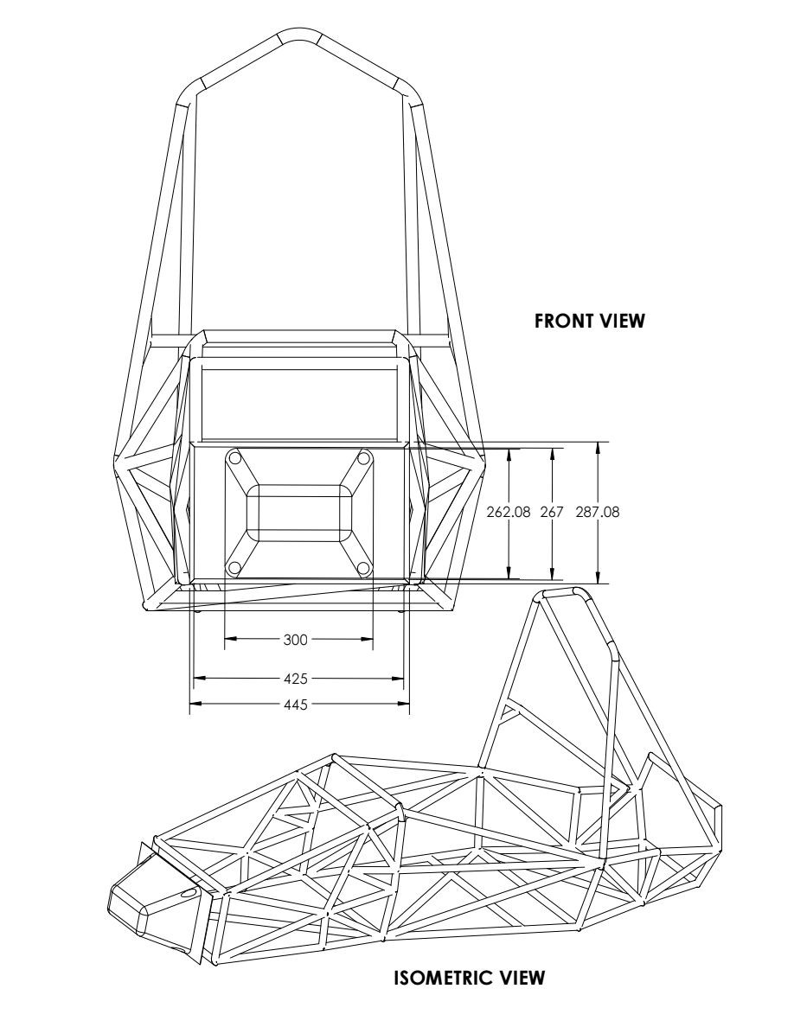

1. Impact Attenuator

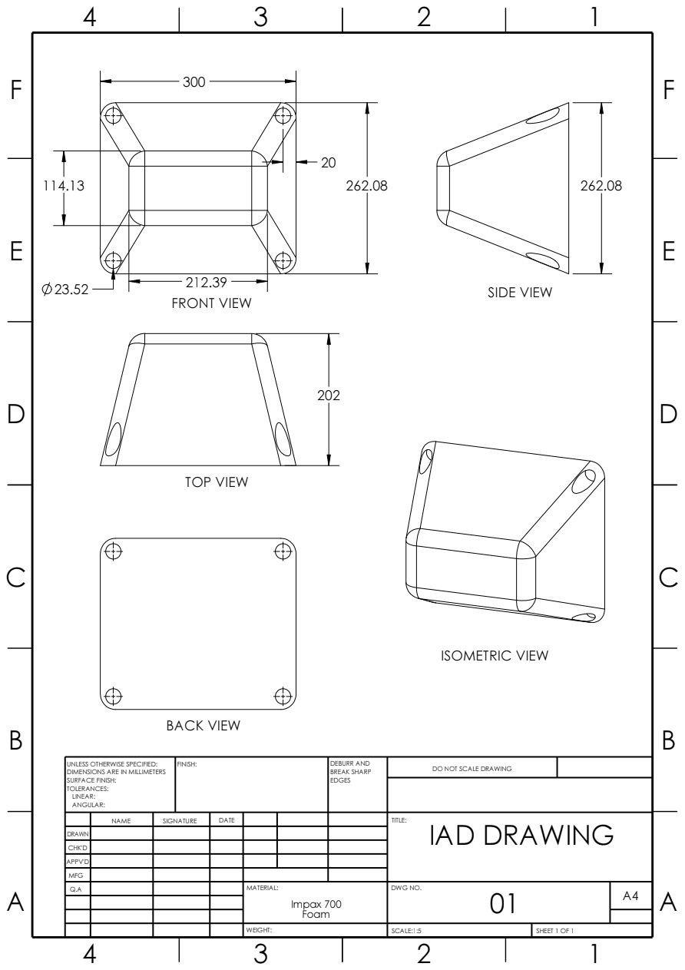

2. Anti Intrusion Plate
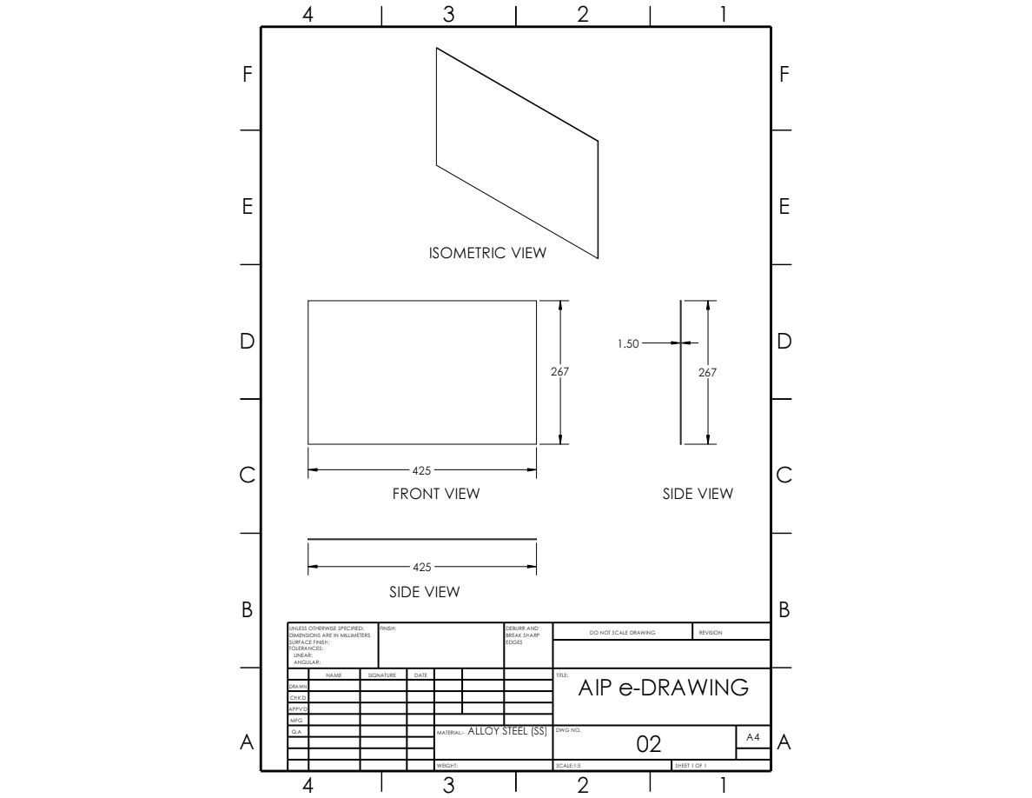

3. IA and AIP Assembly

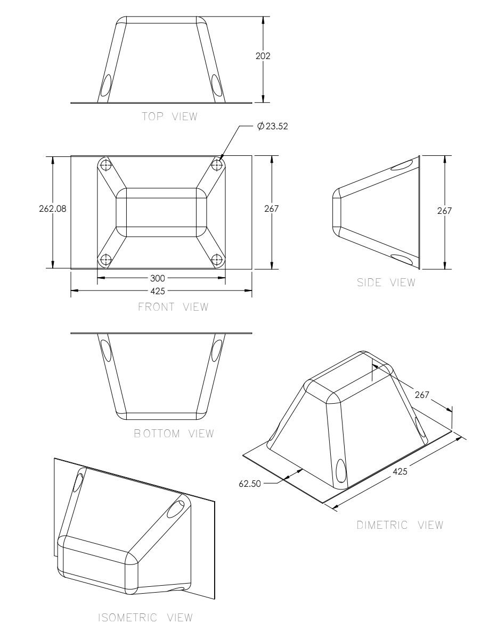

2. RECEIPT

3. Data Sheet

IMPAXX™ 700 Energy Absorbing Foam

IMPAXX™ 700 Energy Absorbing Foam is a higher- performing, and lower-cost alternative to traditional energy absorbing solutions such as polyurethane and expanded polypropylene bead foams.
IMPAXX foam is a highly engineered, extruded, thermoplastic foam that utilizes Dow proprietary process technology to maximize efficiency and minimize weight. It is a strong, low-density, closed-cell foam.
IMPAXX foam is highly suited for applications in a variety of industries requiring enhanced safety features through energy absorbing countermeasures.

Sizes available: sheets, basic blocks and custom-fabricated parts. Color: Blue
Physical Properties¹ | Test Method | Direction | Value
Physical Properties¹ | Test Method | Direction | U.S. / Metric
Density | ASTM D 3575, Suffix W, Method B | N/A | 2.8 pcf
 | DIN 53420 |  | 45 Kg/m^3
Compression Strength | ASTM D1621, 23°C |  | Psi | / kPa
@ 10% |  | Vertical | 101 | / 700
@ 25% |  | Vertical | 104 | / 718
@ 50% |  | Vertical | 121 | / 835
Compression Strength | ASTM D1621, -15°C |  | Psi | / kPa
@ 25% |  | Vertical | 114 | / 788
@ 50% |  | Vertical | 138 | / 954
Compression Strength | ASTM D1621, 60°C |  | Psi | / kPa
@ 25% |  | Vertical | 73 | / 504
@ 50% |  | Vertical | 85 | / 586
Thermal Stability | ASTM D 3575, Suffix S or | N/A | < 2%
(linear change @ 80°C) | DIN 53431
Flammability** | FMVSS 302 | Extrusion | Pass
Fogging | SAE J1756 |  | 100 Fog Number
Water Absorption | ASTM D3575, Suffix L | N/A | 6%

(1) The data presented for this product is for unfabricated foam. While values shown are typical of the product, they should not be construed as specification limits.
** Results from this test do not represent performance under actual fire conditions.
IMPAXX™ foam is globally available. It is an environmentally-friendly, recyclable material and meets governmental flammability requirements for interior automotive components.
IMPAXX foam is a non-CFC, non- HCFC, non-HFC material.

IMPAXX foam is available in a variety of densities and sizes and offers low weight to EA performance characteristics required for automotive applications. IMPAXX foam weighs less than other energy absorbing foams of similar strength. IMPAXX™ foam characteristics remain stable at cold temperatures including -30°C.

Typical automotive applications include:
- Headliner Head Impact Countermeasures
- Pillar Head Impact Countermeasures
- Side Impact Door Countermeasures
- Bumper Systems
- Front Impact Bolster Systems
- Lower Leg Impact Protection
- Structural Panels
  - Load floors
  - Sun shades
  - Sun visors

IMPAXX foam has multiple attachment methods such as: pressure-sensitive tapes and hot-melts, mechanical screws and clips, heat-staking, sonic welding, plus others.

Safety and Handling Considerations

Material Safety Data (MSD) sheets for IMPAXX 700 foams are available from Dow. MSD sheets are provided to help customers satisfy their own handling, safety, and disposal needs.
IMPAXX™ energy absorbing foam meets the requirements of the U.S. Clean Air Act Amendments.

The fabrication of plastic foam can result in the generation of dust. Dust resulting from sawing, filing, and sanding of plastic parts may cause irritation to the eyes and upper respiratory track. Workers should wear appropriate eye protection and protective clothing.

Disposal
Do not dump into sewers, on the ground, or into any body of water. The preferred disposal method is to send to a licensed recycler, reclaimer, or incinerator. All disposal methods must be in compliance with Federal/State/Provincial and local laws and regulations. As a service to its customers, Dow can provide names of information resources to help identify waste management companies and other facilities which recycle, reprocess or manage chemicals or plastics, and that manage used drums. Contact the Dow Customer Service Center for further details.

Combustibility
IMPAXX™ 700 foam is combustible and should not be exposed to flame or other ignition sources.

Product Features

As the properties listed on the reverse side suggest, IMPAXX™ 700 Energy Absorbing Foam offers good strength, vibration and shock absorbency and water resistance characteristics.
IMPAXX 700 Energy Absorbing Foam meets the requirements of the
U.S. Clean Air Act Amendments. It is easily fabricated and non- abrasive.

